A

Mini Project Report on

**ANALYSIS OF AUTOCLAVED AERATED CONCRETE BLOCKS WITH CONVENTIONAL BRICK BLOCKS**

*Submitted for partial fulfilment of the requirements for the award of the degree of*

### BACHELOR OF TECHNOLOGY

**in**

### CIVIL ENGINEERING

### by

|  |
| --- |
| B. SANJANA 21K85A0117  G. DILEEP 21K85A0131  B. PAVAN 21K85A0116  K.JOHN PRASANNA 21K85A0134 |
|  |

Under the Guidance of

**Mrs. K CHAITRA**

 **ASSISTANT PROFSSOR**

# DEPARTMENT OF CIVIL ENGINEERING

|  |
| --- |
| **St. MARTIN'S ENGINEERING COLLEGE** |
| UGC Autonomous  Affiliated to JNTUH, Approved by AICTE Accredited by NBA & NAAC A+, ISO 9001-2008 Certified  Dhulapally, Secunderabad-500 100  www.smec.ac.in |

## DECEMBER – 2023



|  |
| --- |
| **St. MARTIN'S ENGINEERING COLLEGE** |
| UGC Autonomous  Affiliated to JNTUH, Approved by AICTE  NBA& NAAC A+ Accredited Dhulapally, Secunderabad - 500 100 |

**CERTIFICATE**

This is to certify that the project entitled **“Analysis Of Autoclaved Aerated Concrete Blocks With Conventional Brick Blocks”** is being submitted by B. Sanjana (21K85A0117), G. Dileep (21K85A0131), B. Pavan (21K85A0116), K. John Prasanna (21K85A0134)in fulfilment of the requirement for the award of degree of **BACHELOR OF TECHNOLOGY IN CIVIL ENGINEERING** is recorded of bonafide work carried out by them. The result embodied in this report have been verified and found satisfactory.

Signature of Guide Signature of HOD

## Mrs K. CHAITRA Prof. SANDHYA KIRAN J.K.

Assistant Professor Associate Professor and Head of Department

Department of Civil Engineering Department of Civil Engineering

## Internal Examiner External Examiner

Place:

Date :



|  |
| --- |
| **St. MARTIN'S ENGINEERING COLLEGE** |
| UGC Autonomous  Affiliated to JNTUH, Approved by AICTE  NBA& NAAC A+ Accredited Dhulapally, Secunderabad - 500 100 |

**DECLARATION**

We, the students of **Bachelor of Technology** in Department of **Civil Engineering,** session: 2021- 2024**, St. Martin’s Engineering College, Dhulapally, Kompally, Secunderabad,** hereby declare that the work presented in this project entitled **‘Analysis Of Autoclaved Aerated Concrete Blocks With Conventional Brick Blocks’** is the outcome of our own bonafide work and it is correct to the best of our knowledge and this work has been undertaken taking care of Engineering Ethics. The result embodied in this project report has not been submitted in any university for award of any degree.

|  |  |
| --- | --- |
| B.SANJANA | 21K85A0117 |
| G.DILEEP | 21K85A0131 |
| B.PAVAN | 21K85A0116 |
| K. JOHN PRASANNA | 21K85A0134 |

## Acknowledgement

The satisfaction and euphoria that accompanies the successful completion of any task would be incomplete without the mention of the people who made it possible and whose encouragement and guidance have crowded our efforts with success.

First and foremost, we would like to express our deep sense of gratitude and indebtedness to our College Management for their kind support and permission to use the facilities available in the Institute.

We especially would like to express our deep sense of gratitude and indebtedness to **Dr. P. SANTOSH KUMAR PATRA**, Group Director, St. Martin’s Engineering College Dhulapally, for permitting us to undertake this project.

We wish to record our profound gratitude to **Dr. M. SREENIVAS RAO**, Principal, St. Martin’s Engineering College, for his motivation and encouragement.

We are also thankful to **Prof. SANDHYA KIRAN J.K**, Associate Professor, Head of the Department, Information Technology, St. Martin’s Engineering College, Dhulapally, Secunderabad, for his support and guidance throughout our project as well as Project Coordinators **Mrs. K. CHAITRA** Professor and **MR. P. ABHISHEK** Professor, Information Technology department for there valuable support.

We would like to express our sincere gratitude and indebtedness to our project supervisor, **Mrs. K. CHAITRA**, Assistant Professor, Civil Engineering, St. Martins Engineering College, Dhulapally, for his support and guidance throughout our project.

Finally, we express thanks to all those who have helped us successfully completing this project. Furthermore, we would like to thank our family and friends for their moral support and encouragement. We express thanks to all those who have helped us in successfully completing the project.

|  |  |  |  |
| --- | --- | --- | --- |
| B.Sanjana | 21K85A0117 |  |  |
| G.Dileep | 21K85A0131 |  |  |
| B.Pavan | 21K85A0116 |  |  |
| K. John Prasanna | 21K85A0134 |  |  |

# CONTENTS

### **Acknowledgement Ⅴ**

**List of contents Ⅵ**

### **List of figures Ⅶ**

### **List of tables Ⅸ**

**List of charts Ⅹ**

### **Abstract 1**

### **CHAPTER-1 INTRODUCTION** 2

* 1. General introduction 2
  2. Light weight concrete 3
  3. History 4
  4. Types of light weight concrete 6
  5. Materials and their properties of AAC block 9
  6. Advantages, disadvantages and applications of LEC 12
  7. Applications 13
  8. objectives 15

**CHAPTER 2 LITERATURE REVIEW** 16

**CHAPTER 3 METHODOLOGY**  25

### **CHAPTER 4 EXPERIMENTAL STUDY** 28

* 1. Tests 28
  2. Split tensile test 31
  3. Slump cone test 33
  4. Mix design 34

### **CHAPTER 5 RESULTS AND DISCUSSION** 37

5.1 Analysis of slump test results 41

* 1. Analysis of compressive test results 42

5.3 Analysis of split tensile strength results 44

5.4 Tensile bond strength test results 48

5.5 How to avoid cracking in walls with AAC blocks 51

5.6 Advantages and Disadvantages of AAC blocks 53

**CHAPTER 6 CONCLUSION** 55

**CHAPTER 7 FUTURE SCOPE**  57

**CHAPTER 8 REFERENCES** 60

**LIST OF FIGURES**

|  |  |  |  |
| --- | --- | --- | --- |
| **Figure No.** | | **Figure Title** | **Page No.** |
| 1.3 (a) | | pantheon | 4 |
| 1.3 (b) | | Pantheon dome | 5 |
| 1.4.1(a) | | No-fine concrete | 5 |
| 1.4.1(b) | | No-fine concrete cubes | 6 |
| 1.4.2 | Light weight aggregate concrete blocks | | 8 |
| 1.4.3  1.5.1  1.5.2  1.5.3  1.5.4  1.5.5(a)  1.5.5(b)  1.7.1.1  1.7.1.2  1.7.1.3  4.1.1  4.1.3(a)  4.4.3(b)  4.1.3(c)  4.2(a)  4.2(b)  4.3(a)  4.3(b)  5(a)  5(b)  5(c)  5.2  5.4  5.4(a)  5.4(b)  5.4(c) | | Aerated concrete blocks  Cement  Sand  Fly ash  Lime  Aluminum power  Manufacturing process of AAC blocks  Light precast blocks  Hollow concrete planks  Composite roof steel decking  Test on cement  Compressive strength test machine  Compressive strength test molds  casting  split tensile test  split tensile test machine  slump cone test  test on slump  AAC blocks replaced with conventional bricks  Structural construction with AAC blocks  Fly ash from thermal power plants  Conducted compression test on cube  Typical failure behavior of AAC block masonry  Band beam and stud column  Chicken mesh  Adhesive | 9  10  10  11  12  12  13  13  14  14  30  32  32  32  33  34  35  36  37  38  39  43  52  56  57  57 |

**LIST OF TABLES**

|  |  |  |  |
| --- | --- | --- | --- |
| **Table No.** | | **Table Name** | **Page No.** |
| 4.1.1  4.1.2  4.4  5.2  5.3(a)  5.3(b)  5.3(C)  5.3(d)  5.4  5.5 | Physical properties of OPC  Physical characteristics of fly ash  Mix sampling  Average compressive strength    Mix proportions for M20 grade of LWC with 20% GGBS  Compressive strength of M20 grade of normal concrete  Compressive test results of AAC masonry  Tensile bond strength  Comparison between AAC block and clay bricks | 28  29  36  43  45  46  46  47  48  56 |

## LIST OF CHARTS

|  |  |  |
| --- | --- | --- |
| **CHART.NO** | **CHART NAME** | **PAGE NO** |
| 3.0 | AAC manufacturing | 25 |
| 5.1 | Compression of aggregate proportion v/s slump | 41 |
| 5.2 | Compression of aggregate proportion v/s compressive strength | 44 |
| 5.3 | Compression of aggregate proportion v/s split tensile test | 45 |

## ABSTRACT

The traditional bricks are the main building materials that are used extensively in the construction and building industry. Autoclaved Aerated Concrete blocks are recently one of the newly adopted building materials. The Autoclaved aerated concrete (AAC) is a product of fly ash which is mixed with lime, cement, and water and an aerating agent. The AAC is mainly produced as cuboid blocks and prefabricated panels. The Autoclaved aerated concrete is a type of concrete that is manufactured to contain lots of closed air voids. The AAC blocks are energy efficient, durable, less dense, and lightweight. It is manufactured by adding a foaming additive to concrete in different sizes of molds as per requirement, then wire-cutting these blocks or panels from the resulting ‘cake lump’ and ‘heating them with steam. This process is called as Autoclaving. It has been observed that this material is an ecofriendly building material that is being manufactured from industrial waste and is composed of non-toxic ingredients. In this paper, an overview of AAC blocks with reference to its potential and sustainability as a novel building material has been presented. The paper also presents a comparative cost analysis of AAC Blocks with the Red clay bricks and its suitability and potential use in the construction in the building industry.

**Key words:** AAC blocks; Performance, Potential, Walling system; Sustainability.

**CHAPTER-1**

**INTRODUCTION**

**1.1 GENERAL INTRODUCTION**

Concrete is one of the important adhesive materials used in construction field. It is obtained by mixing of cement, fine aggregates, coarse aggregates and water along with some pozzolanas if required in a proportionate way as per the mix design. Increased demand in the construction industry led to increase in the cost of production of concrete. This increased cost of construction materials have paved the way for the researchers to introduce some new construction materials with low cost and high strength. Concrete, due to its high self-weight increases the dead load on the structure. Many research works have been carried out in order to decrease the self-weight of the construction materials on the structure which lead to the development of light weight concrete. With reference to this there is an increase in the demand for light weight concrete due to low density and high strength.

Autoclaved aerated concrete (AAC) is a lightweight, precast, cellular [concrete](https://en.wikipedia.org/wiki/Concrete) building material, eco-friendly, suitable for producing [concrete-like blocks](https://en.wikipedia.org/wiki/Concrete_block). It is composed of [quartz sand](https://en.wikipedia.org/wiki/Quartz_sand), calcined [gypsum](https://en.wikipedia.org/wiki/Gypsum), [lime](https://en.wikipedia.org/wiki/Lime_(mineral)), [portland cement](https://en.wikipedia.org/wiki/Portland_cement), water and [aluminium powder](https://en.wikipedia.org/wiki/Aluminium_powder). AAC products are cured under heat and pressure in an [autoclave](https://en.wikipedia.org/wiki/Autoclave). Developed in the mid-1920s, AAC simultaneously provides structure, insulation, and fire- and [mold](https://en.wikipedia.org/wiki/Mold_(fungus))-resistance. Forms include blocks, wall panels, floor and roof panels, cladding (façade) panels and lintels. AAC is a highly durable material that can last for many years without requiring maintenance. It is also an excellent insulator that can help reduce energy costs by keeping buildings cool in the summer and warm in the winter. Additionally, AAC is resistant to fire and mold, making it a safe choice for construction.

AAC products can be used in almost all construction, such as industrial buildings, residential houses, apartment buildings, and townhouses. Lightweight concrete is used, for example, for exterior and interior walls, firewalls, wet room walls, diffusion-open thermal insulation boards, intermediate floors, upper floors, stairs, opening crossings, beams and pillars. Exterior construction requires some type of applied finish, such as a polymer modified [stucco](https://en.wikipedia.org/wiki/Stucco) or [plaster](https://en.wikipedia.org/wiki/Plaster) compound to guard against the elements, or covered with [siding](https://en.wikipedia.org/wiki/Siding_(construction)) materials such as natural or manufactured stone, veneer [brick](https://en.wikipedia.org/wiki/Brick), metal or [vinyl siding](https://en.wikipedia.org/wiki/Vinyl_siding).[[2]](https://en.wikipedia.org/wiki/Autoclaved_aerated_concrete#cite_note-PCA1-2) In addition to their quick and easy installation, AAC materials can be routed, sanded, or cut to size on-site using a [hand saw](https://en.wikipedia.org/wiki/Hand_saw) and standard power tools with [carbon steel](https://en.wikipedia.org/wiki/Carbon_steel) cutters.

Autoclaved Aerated Concrete is an eco-friendly and certified green building material which is lightweight, load-bearing, high-insulating, durable building blocks and 3 times lighter when compared to red bricks. AAC was developed in 1924 by a Swedish architect, who was looking for alternate building material with properties similar to that of wood – good thermal insulation, solid structure and easy to work with – but without the disadvantage of combustibility, decay and termite damage.

## LIGHT WEIGHT CONCRETE

Light weight concrete is a mixture made with light weight coarse aggregates which gives it characteristic low density. Light weight aggregates are produced from materials such as clay, shale, or slate. Blast furnace slag, natural pumice, vermiculite and perlite can be used as substitutes. It is lighter than the conventional concrete.

Light weight concrete is an amazing human invention which is used in several fields of construction. It has numerous numbers of applications which are immensely important like frames and floors, curtain walls, shell roofs, folded plates, bridges, off-shore oil platforms and precast.

The most significant property of lightweight concrete is reduced weight at no sacrifice in strength. Structural lightweight concrete available today are rotary kiln expanded shale, clay or slate (roughly 80% of structural use) and sintered expanded shale or clay (20%). Lightweight Concrete provides the same compressive strength as normal weight aggregates with approximately the same cement content. A typical performance chart of a given aggregate shows the various strengths attainable with different amounts of cement for both 7-day and 28-day tests.

Composite design, except when beams are encased, assumes no bonding action between the concrete and the steel, even though there is a considerable amount of bond under most conditions of load and building usage. The interaction between the steel and the concrete is obtained through shear connectors, and the loading on the concrete is basically that of bearing, which is directly related to concrete's compressive strength. If the lightweight concrete is comparable in compressive strength to normal weight concrete, the shear capacity (or, more correctly, the bearing capacity) of the connectors should be comparable. Pushout tests on shear connectors in lightweight concrete have indicated comparable values. However, because of some uncertainties of materials and a lack of complete test data to prove this point, many engineers and most connector manufacturers recommend some reduction in permissible load per connector when using lightweight concrete. Generally, 80% to 90% of normal weight concrete capacity is used. On the other hand, many engineers do not require any reduction in their designs. The modulus of elasticity of lightweight concrete differs from normal weight concrete. It can range from one-half to three-fourths of the E-value of normal weight concrete at a given strength level, depending on the weight of the concrete.

**1.3** **HISTORY**

Known history of the use of lightweight concrete starts more than two thousand years ago in the Roman Empire. The most significant examples of that time were the Port of Cosa, the Pantheon Dome, and the Colosseum (ACI Committee 213, 2003).

The Port of Cosa was built on the west coast of Italy, in 273 B.C. The structural designers of the port knew lightweight aggregates were more convenient to use in marine structures. Instead of using locally available aggregates (beach sand and gravel) for the construction, the builders have brought natural lightweight aggregates (pumice and scoria) from the volcanic resources which were located around 40 km away from the Port of Cosa.

"The Pantheon' has been constructed using pumice, the most common type of aggregate used in that particular year. From there on, the use of lightweight concrete has been widely spread across other countries such as USA, United Kingdom, and Sweden. The building of ‘The Pantheon’ of lightweight concrete material is still standing eminently in Rome until now for about 18 centuries. it shows that the lighter materials can be used in concrete construction and has an economical advantage.



FIG.1.3 (a) Pantheon



FIG.1.3 (b) Pantheon Dome

## 1.4 TYPES OF LIGHT WEIGHT CONCRETE

Lightweight concrete can be prepared either by injecting air in its composition Orit can be achieved by omitting the finer sizes of the aggregate or even replacing them by a hollow, cellular, or porous aggregate. Particularly, lightweight concrete can be categorized into three groups

No-fines concrete

1.Lightweight aggregate concrete

2.Aerated/Cellular concrete

## NO-FINES CONCRETE

## 

## Fig-1.4.1(a): No-fines concrete

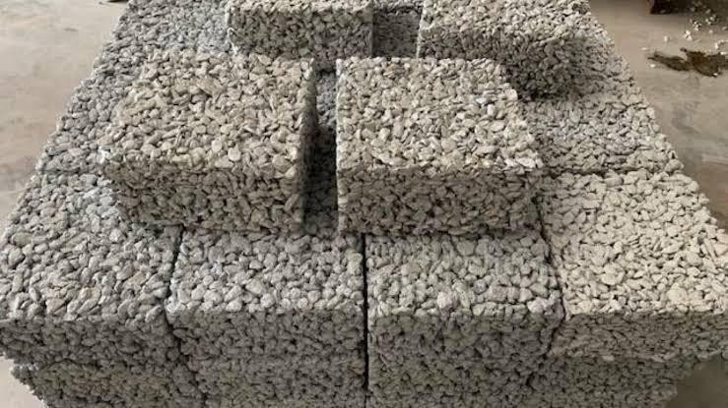No-fines concrete as the term implies, is a kind of concrete in which the Fine Aggregate is not used. This concrete is made up of only coarse aggregate, cement, and water. Only single sized Coarse Aggregate is used. Uniformly distributed voids are formed throughout its mass. The practice of using preformed foam with slurry is limited to small scale production. But the advantage is that any density can be made in this method. No-fines concrete is usually used for both load bearing and non-load bearing for external walls and partitions. The strength of no-fines concrete increases as the cement content is increased.

FIG.1.4.1(b) No-Fines Concrete cubes

## ****Lightweight Aggregate Concrete****

### In the early 1950s, the use of lightweight concrete blocks was accepted in the UK for load bearing inner leaf of cavity walls. Soon thereafter the development and production of new types of artificial LWA (Lightweight aggregate) made it possible to introduce LWC of high strength, suitable for structural work.

These advances encouraged the structural use of LWA concrete, particularly where the need to reduce weight in a structure was in a structure was an important consideration for design or for economy.

**Listed below are several types of lightweight aggregates suitable for structural reinforced concrete:-**

**1.Pumice** – is used for reinforced concrete roof slab, mainly for industrial roofs in Germany.

**2.Foamed Slag** – was the first **lightweight aggregate**suitable for reinforced concrete that was produced in large quantity in the UK.

**3.Expanded Clays and Shales** – capable of achieving sufficiently high strength for prestressed concrete. Well established under the trade names of Aglite and Leca (UK), Haydite, Rocklite, Gravelite and Aglite (USA).

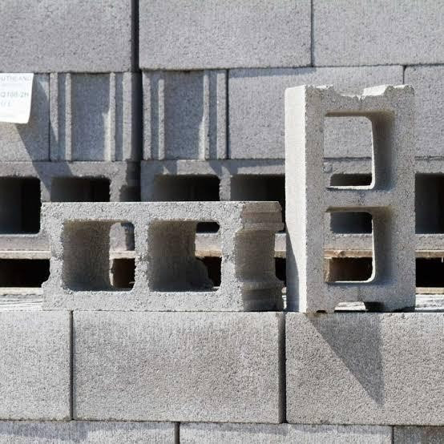**4.Sintered Pulverised***–* fuel ash aggregate – is being used in the UK for a variety of structural purposes and is being marketed under the trade name Lytag.

FIG.1.4.2 Light weight aggregate concrete blocks

## AERATED OR CELLULAR CONCRETE

Aerated concrete does not contain coarse aggregate, and can be regarded as an aerated mortar. Typically, aerated concrete is made by introducing air or other gas into a cement slurry and fine sand. In commercial practice, the sand is replaced by pulverized fly ash or other siliceous material, and lime may be used instead of cement.

There are two methods to prepare the aerated concrete. The first method is to inject the gas into the mixing during its plastic condition by means of a chemical reaction. The second method, air is introduced either by mixing-in stable foam or by whipping-in air, using an air-entraining agent. The first method is usually used in precast concrete factories where the precast units are subsequently autoclaved in order to produce concrete with a reasonable high strength and low drying shrinkage. The second method is mainly used for in-situ concrete, suitable for insulation roof screeds or pipe lagging.

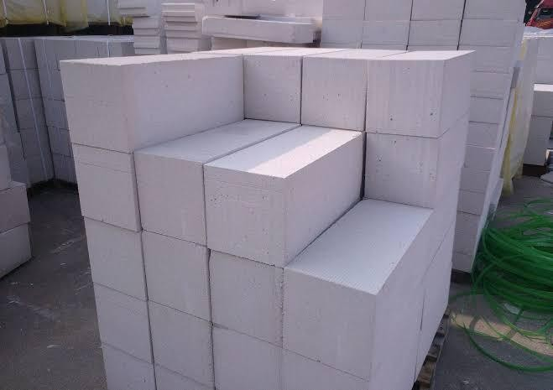

FIG.1.4.3 Aerated Concrete Blocks

## MATERIALS AND THEIR PROPERTIES OF AAC BLOCKS

* + 1. **CEMENT**

A cement is a [binder](https://en.wikipedia.org/wiki/Binder_(material)), a [chemical substance](https://en.wikipedia.org/wiki/Chemical_substance) used for construction that [sets](https://en.wikipedia.org/wiki/Solidification), hardens, and adheres to other [materials](https://en.wikipedia.org/wiki/Material) to bind them together. Cement is seldom used on its own, but rather to bind sand and gravel ([aggregate](https://en.wikipedia.org/wiki/Construction_aggregate)) together. Cement mixed with fine aggregate produces [mortar](https://en.wikipedia.org/wiki/Mortar_(masonry)) for masonry, or with [sand](https://en.wikipedia.org/wiki/Sand) and [gravel](https://en.wikipedia.org/wiki/Gravel), produces [concrete](https://en.wikipedia.org/wiki/Concrete). Concrete is the most widely used material in existence and is behind only water as the planet's most-consumed resource.

Cement is the most important ingredient which determines the fresh & hardened properties of concrete. Cement is a binder, a substance used in construction industry that sets and hardens and can bind other materials together. Density of cement -1440kg/m.

Ordinary Portland cement of 43 grade (specific gravity-3.15) confirming to IS 12269-1987 is used.

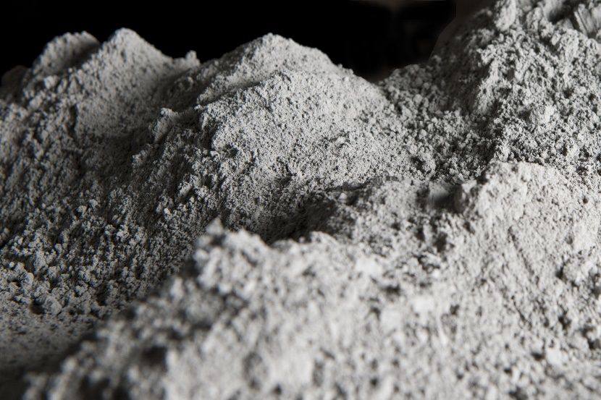

1.5.1 Cement

## FINE AGGREGATES

The aggregates which are passing through 4.75mm size IS sieve and contains only that much of coarse-grained materials as permitted by the specifications are generalized as fine aggregates. Fine aggregates confirming to zone II passing through 4.75mm IS sieve (specific gravity-2.52) is used.

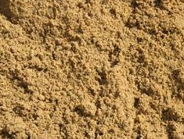

## 1.5.2 Sand

## FLY ASH

Fly ash is waste industrial product used for reduction of construction cost. The density of fly ashranges from 400-1800kg/m. It provides thermal insulation, fire resistance and sound absorption. The type of flyash used is of Class C with contains 20% lime (CaO) and loss of ignition not be more than 6%, for powdered fly ash.

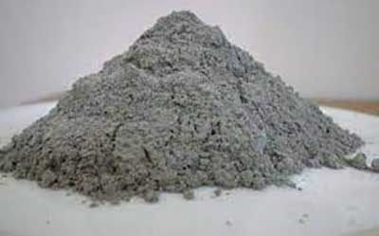

1.5.3 fly ash

## LIME

Quicklime (or calcium oxide or burnt lime) is obtained by calcining pure limestone at temperature above 9000C. This highly reactive product is essential to many industrial processes. Calcium oxide (CaO), commonly known as quicklime or burnt lime, is a widely used chemical compound. It is a white, caustic, alkaline, crystalline solid at room temperature. The broadly used term lime connotes calcium-containing inorganic materials, in which carbonates, oxides and hydroxides of calcium, silicon, magnesium, aluminium, and iron predominate.

## http://shreegannayakminerals.com/img/limepowder.jpg

## 1.5.4 lime

## Aluminium power

Aluminum is an expansion agent. When the raw material reacts with aluminium powder, air bubble introduced due to reaction between calcium hydroxide, aluminium and water and hydrogen gas is released.

2Al+3Ca(OH)2 + 6H2O 3CaO.Al2O3.6H2O + 3H

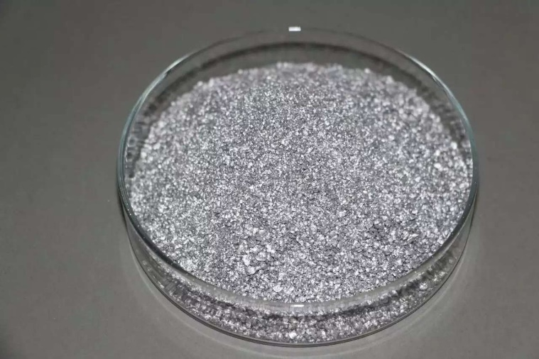

1.5.5(a) aluminium power

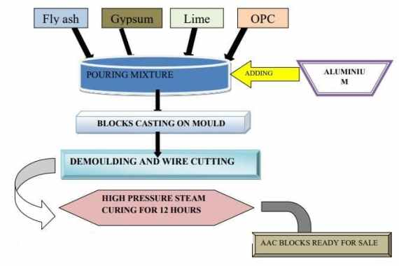

1.5.5(b)manufacturing process of AAC blocks

* 1. **ADVANTAGES, DISADVANTAGES AND APPLICATIONS OF LWC**

## 1.6.1 ADVANTAGES

* Helps in reduction of dead loads.
* Increases the progress of the building.
* Lowers the haulage and handling cost.
* Overall weight of the building is reduced resulting in the corresponding reduction in the
* size of the foundation.
* The formwork needs to withstand a lower pressure than ordinary concrete.
* Has low thermal conductivity. A property, which improves with decreasing density.
* Result in enhanced thermal comforts and lower power consumption.
* Gives an outlet for industrial waste such as fly ash, slag etc.

## 1.6.2 DISADVANTAGES

* Very sensitive with water content in the mixtures.
* Difficult to place and finish because of the porosity and angularity of the aggregate. In some mixes the cement mortar may separate the aggregate and float towards the surface.
* Mixing time is longer than conventional concrte to assure proper mixing.
* The depth of carbonation i.e. the depth within which corrosion can occur under suitable conditions is nearly twice than that of normal concrete.

¬ Color- White

¬ Type –OPC Grade 53

¬ Compressive strength – 53 MPa

¬ Codal provision – IS 269:1989 and IS 383:1970

¬ Chemical compostion of cement

6 |

## APPLICATIONS

* + 1. **ARCHITECHTURAL APPLICATIONS**

Improved structural efficiency in terms of strength/weight ratios resulting load reduction on the structure and substructure, fewer structural components resulting in more usable space in the structure, a reduction in the number and size of reinforcements, increased flexibility in absorbing strains and improved thermal properties minimizing the effects of differential temperatures resulting in building energy conservation as well as improved fire/spilling mitigation.

## LIGHT PRECAST BLOCKS

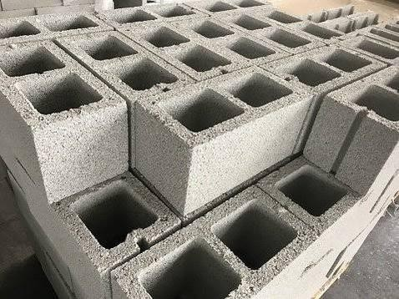It is ideally suited for precast concrete products as larger units can be handled with the same handling equipment or manually for same size units, resulting in speed and economy in construction. These units in addition to smaller ones can be lifted or managed by down-sizing machinery resulting in reducing site carnage requirements and maximizing the number of concrete elements on trucks without exceeding highway load limits reducing transportation delivery cost.

FIG.1.7.1.1 Light precast blocks

## HOLLOW CORE

Hollow core concrete planks and wall panels products are one of the most advanced building materials being used in the construction industry today. The advantage of these extruded wall panels is in durability. They offer outstanding reductions in sound transmission and can obtain fire ratings of up to 4 hours. The problem with this product it has very little or if any insulation properties.

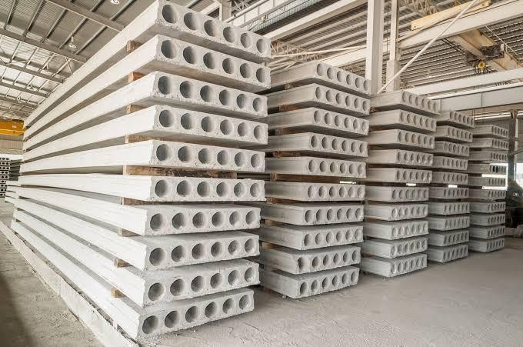

FIG.1.7.1.2 Hollow Concrete Planks

## COMPOSITE ROOF AND FLOOR STEEL DECKING

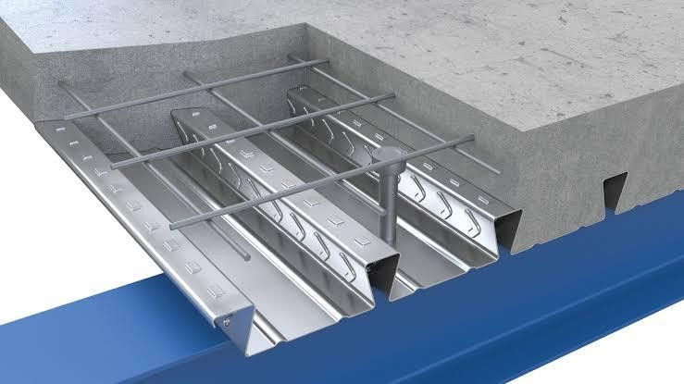Application for insulated properties as well as a sound barrier for lightweight composite roof or floor deck in commercial, industrial, residential buildings/structures. This would especially true for power utility problems currently being experienced in hot and cold regions where electricity, gas or oil consumption is an issue. Heating and cooling costs are reduced.

FIG.1.7.1.3 Composite Roof Steel Decking

## GEOTECHNICAL APPLICATIONS

1. Thermal Fills
2. Pavement Base
3. Controlled Structural Fill
4. Anti-corrosion Fill
5. Erosion Control / Soil Stabilization
6. Conduit / Pipe Bedding
7. Bridge Approach / Abutment
8. Insulating / Isolation Fills
9. Site Reconstruction
10. Void filling for abandoned underground and mining facilities, wells, tunnel shafts, or additional cavity fill.

**1.8 OBJECTIVES**

* To construct economical buildings (cost comparison) by replacing clay bricks by AAC blocks.
* To make productive use of recycled industrial waste (fly ash).
* To cast standard AAC blocks in the laboratory and conduct various tests to check the strength and capacity of blocks.
* To analyze and compare between AAC blocks and conventional clay bricks.

**CHAPTER-2**

# LITERATURE REVIEW

**INTRODUCTION:** In this chapter it is to research and gather various author results and following papers are explained below.

**1. Akshay gupta, Gaurav Kumar Meena, Vaibhav singhal [2023]:**

Autoclaved [aerated concrete](https://www.sciencedirect.com/topics/engineering/aerated-concrete) (AAC) masonry is popularly used for the construction of infill and partition walls in the RC and steel-framed structures. However, past research highlighted that AAC masonry may exhibit poor performance during seismic events due to its low tensile capacity. In this study, the flexural and shear performance of AAC masonry was enhanced by using the fabric-reinforced [cementitious matrix](https://www.sciencedirect.com/topics/engineering/cementitious-matrix) (FRCM). This strengthening scheme was applied in two modes: direct mode using anchor and sandwich method using adhesive mortar. These strengthening schemes were different from each other in the method of placing of the fabric. The experimental results showed that the proposed strengthening methods could improve the strength and ductility of the masonry under shear and flexural loads. The test results showed comparable strengths for both types of strengthening methodologies and either of two methods of fabric application may be chosen for the strengthening of AAC masonry, depending on the availability of materials and ease in construction. Moreover, the outcome of the conducted tests were compared with the respective theoretical predictions estimated using available analytical models and equations.

**2. Abhilasha, Rajesh Kumar, Rajni Lakhani [2023]:**

Autoclaved aerated concrete (AAC) is the lightest masonry material available in today’s building industry. It shows properties, such as high strength per unit weight, lesser density, lower shrinkage, higher thermal insulation, and fire resistance as compared to traditional concrete. Not only engineering properties of AAC make it popular in construction industry, but also its eco-friendly nature also contributes in conservation of energy. AAC produces about 67% lower carbon emission than the clay bricks. Consequently, it becomes a cost-effective product which reduces the cost of construction. This paper provides thorough insight into possible solutions for the waste utilization. It has been inferred that fine aggregates can be replaced by these wastes in the preparation of AAC. This replacement will improve its physio-mechanical properties, such as bulk-density, moisture absorption, compressive strength, along with microstructure. These properties are comprehensively presented to categorize the investigation which has been done in such fields earlier. The ongoing research work at the author’s institute, i.e., the development of lightweight concrete by using different kind of waste materials, such as marble slurry, fly ash, etc., is being presented.

**3. M.Kalpana, S.Mohith [2020] :**

Aerated lightweight concrete have many advantages when compared with conventional concrete such as advanced [strength](https://www.sciencedirect.com/topics/materials-science/mechanical-strength) to weight ratio, lower coefficient of thermal expansion, and good sound insulation as a result of air voids within aerated concrete. Here by studying various research papers the change in properties of AAC has been studied and the production method is classified for each foamed and autoclaved concrete. The literature review of aerated lightweight properties is focus on the porosity, permeability, [compressive strength](https://www.sciencedirect.com/topics/materials-science/compressive-strength) and splitting [strength](https://www.sciencedirect.com/topics/materials-science/mechanical-strength).

**4. Raj, Amit, S. uday [2020] :**

Autoclaved Aerated Concrete (AAC) is a light-weight building-construction product of fly ash, sand, water, cement, lime and aluminum powder, which is used globally for brickwork. The available AAC blocks have smooth surfaces, due to which they have less bond strength than traditional clay bricks. In this work, first, the mechanical properties of AAC block and its masonry were investigated. A simple analytical model was proposed to evaluate the elastic modulus of masonry prism and was found to be in a close agreement with experiments. Two methods have been proposed to improve the shear bond strength of AAC block. In one method, grooves are introduced on the surface of AAC block akin to a frog in clay brick. With two grooves on the surface of AAC block, shear bond strength enhanced by about 46% without having any adverse effect on the compressive strength. An analytical model was developed to explain the phenomenon of strength enhancement. In the other method, the bond strength in the masonry was enhanced by cement-coating the bonding surface before the application of the mortar. To assess the method, the bond strength (both tensile and shear) of AAC block-mortar interface made of ordinary sand-cement mortar of different compositions and polymer modified mortars (PMM) was studied Afterwards, the block surfaces were coated with a 0.6−0.8 mm thick cement-slurry before applying a 12 mm thick sand-cement mortar. A cost analysis was also carried out to see the impact of cement coating. Considering the bond strength as well as cost, using a lean mortar (cement to sand ratio by weight of 1:6) along with cement-slurry coating was found to be superior to the ordinary sand-cement mortar and polymer modified mortar. A finite element model was developed to assess and analyze the experimental findings. The finite element micro-modeling, governed by plastic-damage constitutive relation in tension and compression, along with cohesive zone, was used to model the AAC block and mortar. A good agreement between experimental and computational results was obtained; however, a detailed analysis is still needed. The proposed methods were found to be effective in enhancing the shear bond strength in the masonry. The method of applying cement coating has been found more effective out of the two methods.

**5. Deepak Khanal, Anjay Kumar,Mishra [2020] :**

The increasing demand of construction is a challenge to be fulfilled in this regard different new construction materials are found to be utilized differently. One of the wall construction materials Autoclaved Aerated Concrete Block (AAC) is found to be used in Bharatpur Metropolitanof Nepal. The purpose of this research is to assess the technical suitability of Autoclaved Aerated Concrete Block as Alternative Building Construction Material for the construction of residential buildings and hotels. Laboratory test of the AAC blocks ware done. Quality control chart and t-test ware done for analysis. To test the physical properties, 5 samples of AAC block were observed for compressive strength, density andwater absorption. The compressive strength of the AAC block was found to be 4.324 N/mm2 even with a low density of 617.6 kg/m3when compared to a 3.402 N/mm2 average compressive strength of brick of 1685.8 kg/m3 density. However, the water absorption of the AAC block wasfound higher than that of the Clay brick.

**6. N. Vatin, S.V. Koniyenko, A.S. Gorshkov [2020] :**

The characteristics of autoclaved aerated concrete blocks was tested and analyzed in comparing with Standards' requirements. The results of the study show that the actual thermophysical characteristics of autoclaved aerated concrete blocks, cut from product samples of the three largest manufacturers, in most cases do not coincide with the values declared by the manufacturers and presented in the standards prepared with their direct participation. The mismatch between the calculated and actual values of the thermal conductivity of materials and products used in the installation of external walling, leads to an increase in transmission heat losses through the external walls and the waste of thermal energy for heating and ventilation of buildings. In this regard, a radical review of the values declared by manufacturers, as well as the standards on the basis of which the products are manufactured, and their correct presentation in the current regulatory documents are required.

**7. Mohammad, Arif Kamal [2020] :**

The traditional bricks are the main building materials that are used extensively in the construction and building industry. Autoclaved Aerated Concrete blocks are recently one of the newly adopted building materials. The Autoclaved aerated concrete (AAC) is a product of fly ash which is mixed with lime, cement, and water and an aerating agent. The AAC is mainly produced as cuboid blocks and prefabricated panels. The Autoclaved aerated concrete is a type of concrete that is manufactured to contain lots of closed air voids. The AAC blocks are energy efficient, durable, less dense, and lightweight. It is manufactured by adding a foaming additive to concrete in different sizes of molds as per requirement, then wire-cutting these blocks or panels from the resulting ‘cake lump’and ‘heating them with steam. This process is called as Autoclaving. It has been observed that this material is an ecofriendly building material that is being manufactured from industrial waste and is composed of non-toxic ingredients. In this paper, an overview of AAC blocks with reference to its potential and sustainability as a novel building material has been presented. The paper also presents a comparative cost analysis of AAC Blocks with the Red clay bricks and its suitability and potential use in the construction in the building industry.

**8. Hassavathu Durga, Prasad, Chava Srinivas [2020] :**

Autoclaved aerated concrete blocks are light in weight and density varies from 450-950 kg/Cum, that reduces the dead load of the main structure and have better earthquake resistance, have high compressive strength, has better moisture resistance, have better sound insulation property and absorbs less water, has better fire resistance and available in big blocks and requires less mortar, therefore it increases the speed of construction, so economical too when it is compared to conventional clay bricks. But, the AAC blocks show cracks on the surface due to loading, change in temperature, provision of reinforcement and seismic zoning, and in this paper, a study is carried out to reduce the crack formation and solutions to reduce or to eliminate the crack.

**9. Amit raj, Borsaikia AC, Dixit US [2019] :**

Autoclaved [Aerated Concrete](https://www.sciencedirect.com/topics/engineering/aerated-concrete) (AAC) blocks are used for both load bearing and non-load bearing masonry walls. The tensile and shear strengths of such walls are greatly affected by the bond strength of block-mortar interface. This article investigates the bond strength of AAC block-mortar interface made of ordinary sand-cement mortar of different compositions and polymer modified mortars. A method of improving the bond strength (both tensile and shear) of ordinary sand-cement mortar without altering the block surface characteristics is proposed. In this method, the block surfaces are coated with a thin cement-slurry coating before applying a thick sand-cement mortar. For all types of interfaces, the shear bond strength of the masonry was studied using a triplet test, while the tensile bond strength was determined based on a cross-couplet test. The failure patterns during the [bond strength tests](https://www.sciencedirect.com/topics/engineering/bond-strength-test) were studied. Subsequently, costs were estimated for AAC walls of different types of interfaces. Considering the bond strength as well as cost, using a weak mortar along with cement-slurry coating was found superior to the ordinary sand-cement mortar and polymer modified mortar.

**10. Bhosale.A, Zade.N.P, Davis.R [2019] :**

The strength and stiffness characteristics of infill masonry wall significantly influence the behavior of reinforced concrete framed structures. Although such characteristics for conventional masonry infill walls, like clay and fly ash bricks, are well documented in the literature, experiments for the evaluation of similar properties for modern infill walls using autoclaved aerated concrete (AAC) blocks are limited. This paper reports the experimental results of an investigation of the structural properties of AAC block masonry required for mathematical modeling of AAC masonry-infilled framed structures. It also investigates some of the physical properties of AAC blocks that influence their structural properties and overall behavior.

**11. Amit raj, Arun Ch Borsaikia, Uday.S [2019] :**

Autoclaved aerated concrete (AAC) is a light-weight cementitious product of sand, water, cement, lime and aluminium powder mix, used globally for brickwork. The AAC blocks in vogue have smooth surfaces, due to which they have less bond strength than that of traditional clay bricks. This work asserts that the shear bond strength of AAC masonry can be enhanced by using grooved AAC blocks. The compressive strength of the grooved AAC block as well as the shear bond and compressive strengths of the masonry have been investigated experimentally and compared with conventional AAC blocks and masonry. The study clearly demonstrated the superiority of grooved AAC blocks to conventional AAC blocks. Simple analytical models have been developed to estimate the masonry compressive and shear bond strengths. Analytical models are capable of obtaining lower, upper and most likely estimates of strengths. Significance tests have been carried out to support the findings.

**12. Nguyen Trong Lam Shingo, Asamoto, Kunio Matsui [2018] :**

We investigated the microstructure and shrinkage behavior of autoclaved aerated concrete (AAC) from several manufacturers in Vietnam comparing with Japanese AAC. Three types of Vietnamese AAC and one type of Japanese AAC were used for powder X-ray diffraction, scanning electron microscopy, mercury intrusion porosimetry, and shrinkage tests. The experimental results show that the main hydration products of AAC that used fly ash as silica materials is semi-crystalline calcium silicate hydrate, while the ones of others are tobermorite; but the tobermorite crystals of AACs from some manufacturers in Vietnam are disordered structures and lack of interlocking among tobermorite crystals. The pore size distribution of all Vietnamese AAC are single peak, whereas Japanese AAC is bimodal. The pore distribution characteristics of AACs significantly influenced their shrinkage behavior and the shrinkage of Vietnamese AAC is higher than that of Japanese AAC at intermediate relative humidity (RH). The capillary tension is the principle shrinkage mechanism for AAC materials at high RH (above about 65%) to cause local minimum shrinkage of Japanese AAC at high RHs, while the change in surface free energy is dominant at low RH conditions.

**13. Satish Kumar. B, Sukumar. R, Srinath. G. S [2017] :**

At present, construction works, such as high-rise buildings or offices and residential houses, in many countries are growing very fast every year. The accumulation of heat and moisture in building wall plays an important role in its maintenance and energy conservation.AC block, an ecofriendly material, gives a prospective solution to building construction. The usage of AC block reduces the cost of construction up to 20% as reduction of dead load of wall on beam. The use of AC block also reduces the requirement of materials up to 50%.Aerated concrete can produce a light weight, environmentally friendly, lower coefficient of thermal expansion, mould resistance, reduced dead weight and good sound insulation as a result of air voids within aerated concrete this block no coarse aggregates in its mixture the blocks are manufactured by precast technique it is produced by mixing of Portland cement, fly ash, water, lime and Aluminium powder. AC products include blocks, wall panels, floor and roof panels, and lintels.

**14.Jan kubica, Iwona Galman [2017] :**

In modern architecture, especially in dwelling buildings, one of the most popular and frequently used materials for construction of load-bearing walls are AAC blocks with thin layer joints. Such type of masonry units is recommended for construction of masonry walls with unfilled head (horizontal) joints. Construction speed using this technology is higher and brick work is easier. Unfortunately, there is also a negative aspect of unfilled head joints: such walls are characterised with low crack resistance, especially in case of shearing loads. This is a common problem in the buildings located in the areas of seismic influences, but also in buildings subjected to uneven settlements. One of the solutions to improve the crack resistance of the masonry walls made of AAC blocks is application of superficial strengthening using CFRP mats. This paper presents the results of laboratory tests which investigated the effectiveness of strengthening with carbon fibres strips in different assembly configurations. Three series of masonry specimens were tested: unstrengthened wallettes, small rectangular walls with strengthening on both sides with strips mounted on the surface and covering the head joints, and specimens with strengthening also on both sides but with CFRP strips mounted outside of the head joints. All specimens were subjected to diagonal compressive loading according to RILEM LUMB 6 recommendations. An increase of shear capacity of both types of strengthening with respect to the unreinforced elements was observed. In general, a positive effect of external strengthening was defined, however, the tests also showed that the number of CFRP strips can be reduced and what are their recommended location as well as orientation in relation to bed joints.

**15. A.Farid, A.Aidan, T.Ibrahim [2017] :**

Autoclaved aerated concrete (AAC) is an environmentally friendly material that has several advantages such as heat insulation, sound insulation, and light weight which reduce the energy consumption of a structure during its construction and when using it. However, the compressive strength of AAC is relatively low in comparison with concrete masonry units that are used as building blocks. This paper provides insight into a newly proposed AAC-concrete sandwich composite. The main aim of this research is to produce a lightweight eco-friendly loadbearing building block. Construction and demolition wastes including the cement and ﬁne powder waste were utilized to generate the AAC-concrete composite.

The proposed sandwich composite was tested in a number of stages. Firstly, a preliminary test was conducted to test the proposed sandwiching technique. Three sets of plain sandwich specimens were prepared, each with a diﬀerent combination of AAC thickness and concrete thickness. It was found that the proposed composite had a higher compressive strength than AAC and a lower density than the normal concrete. Secondly, diﬀerent concrete and mortar mixes were prepared and studied to identify the mix that would yield the best sandwich composite. This best mix was identiﬁed and used throughout the experiment. Thirdly, diﬀerent sandwiching techniques were applied to enhance bonding at the AAC-concrete interface. The proposed sandwiching techniques were as follows: inserting grooves at the AAC-concrete interface and wrapping the AAC block with wire mesh. Multiple cube specimens with 10 cm side length were prepared and tested for their compressive strength. It was found that the wire mesh provided a more eﬀective bonding. Finally, additional grooved and plain sandwich cube specimens with 20 cm side length were prepared and tested under diﬀerent quasi-static loading rates. Unlike plain sandwich block, the compressive behavior of grooved sandwich showed a slight increase in its capacity at higher quasi-static rate. Almost all specimens in this study failed in a similar manner that is, by debonding at the AAC-concrete interface, followed by crushing.

**16. Annalisa rosit, Andrea penna [2016] :**

An experimental campaign aiming at investigating the seismic performance of unreinforced masonry low-density autoclaved aerated concrete blocks is presented. After characterization tests on blocks, mortar and wallettes, in-plane cyclic tests on six full-scale unreinforced masonry piers were performed to obtain a reliable description of the lateral cyclic behavior. Information regarding the displacement capacity and the correlation between experimental and analytical strengths were derived. The results show a limited in-plane displacement capacity of piers, strongly depending on the applied vertical load, and a good correlation between experimental and calculated lateral strengths. At the end of the cyclic tests, the residual vertical strength of some walls was also directly checked.

**Conclusion:** The literature review on AAC (Autoclaved Aerated Concrete) blocks highlights a growing interest in this innovative building material within the construction industry. Through an examination of the existing body of research, several key findings and trends have emerged.

# CHAPTER-3

# METHODOLOGY

# 3.0 chart of AAC manufacturing

1.Raw Materials Preparation:

* Sand: Sand is the primary raw material, typically sourced from quarries.
* Cement: Ordinary Portland cement is used as a binder.
* Lime: Lime may be added to enhance the properties of AAC blocks.
* Aluminum Powder: Fine aluminum powder acts as a foaming agent.
* Gypsum: Gypsum is used to control the setting time of the mixture.
* Water: Clean water is needed for mixing.

2.Mixing:

* The raw materials are mixed in the right proportions. The key to AAC's lightweight properties is the addition of aluminum powder, which creates hydrogen gas when mixed with water.

3.Aerating:

* The aluminum powder-water mixture is added to the cement-sand mixture.
* The aluminum reacts with the calcium hydroxide released by the cement, producing tiny hydrogen bubbles that aerate the concrete.
* This aerated mixture is poured into molds.

4.Molding:

* The mixture is poured into rectangular molds of various sizes.
* The molds are then placed in a controlled environment where the mixture expands and hardens.

5.Curing:

* The green AAC blocks are subjected to curing, often in an autoclave (a high-pressure steam chamber).
* Curing may last several hours to ensure the blocks gain their final strength.
* Steam and pressure accelerate the chemical reactions within the mixture.

6.Cutting:

* Once cured, AAC blocks are cut into precise dimensions using specialized cutting machines.
* These blocks are cut into various sizes to suit construction needs.

7.Quality Control:

* Quality control checks are performed to ensure the blocks meet specified standards for density, strength, and other properties.

8.Packaging and Transportation:

* After quality control, the AAC blocks are packaged and prepared for transportation to construction sites.

9.Construction:

* AAC blocks are used in various construction applications, including load-bearing walls, non-load-bearing walls, partitions, and more.
* They are often laid with thin-bed mortar or adhesive due to their precise dimensions.

10.Finishing:

* After construction, AAC blocks can be finished with plaster, paint, or other wall coverings.

The methodology of AAC block production focuses on the precise mixing of raw materials, controlled aeration, curing, and quality control to ensure consistent and high-quality blocks. The lightweight, thermal insulation, and structural properties of AAC make it an attractive choice in many construction projects.

**CHAPTER-4**

**EXPERIMENTAL STUDY**

## TESTS

OPC of 53 Grade produced by Ramco Cements Limited was used in this project. The cement needed for the experiments was obtained from a single source. The Physical properties of cement determined and tabulated in below table 4.1.1.

Table 4.1.1: Physical Properties of Ordinary Portland Cement.

|  |  |  |  |
| --- | --- | --- | --- |
| **Property** | **As per the Test** | **As per I.S. Code** | **I.S. Code Referred** |
| Specific Gravity | 3.13 | ≈3.15 | IS 2720 Part3-1980 |
| Density | 1447kg/m3 | ---- | IS 4031 Part11-1988 |
| Fineness | 0.04% | <0.1% | IS 4031 Part1-1996 |
| Normal Consistency | 34% | ---- | IS 4031 Part4-1988 |
| Initial Setting Time | 46 minutes | ≥30minutes | IS 4031 Part5-1988 |
| Final Setting Time | ≈600 minutes | ≤600 minutes |

* + 1. Tests On Cement



**4.1.2 Fly Ash**

Table 4.1.2: Physical characteristics of Fly ash

|  |  |  |  |
| --- | --- | --- | --- |
| **Test** | **Result obtained** | **Result based on IS** | **IS Code** |
| **Fineness** | 0% | < 0.1% | IS 3812 Part 1 - 2013 |
| **Specific Gravity** | 2.85 | 1.9-2.96 |
| **Density** | 1250 Kg/m3 | ----- |

* + 1. **Compressive Test**

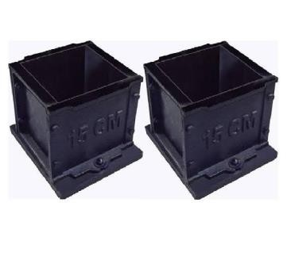Compressive strength is the primary physical property of concrete and is the one most used in design. It is one of the fundamental properties used for quality control for lightweight concrete. Compressive strength may be defined as the measured maximum resistance of a concrete specimen to axial loading. It is found by measuring the highest compression stress that a test cylinder or cube will support. There are three type of test that can be use to determine compressive strength ; cube, cylinder, or prism test. The 'concrete cube test' is the most familiar test and is used as the standard method of measuring compressive strength for quality control purpose. The cubes are generally tested at 7 & 28 days unless specific early tests are required and Strength of concrete increase with age.

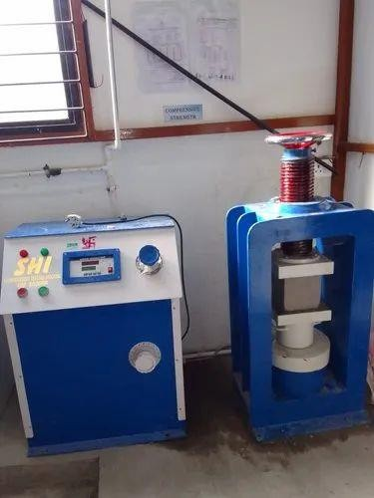

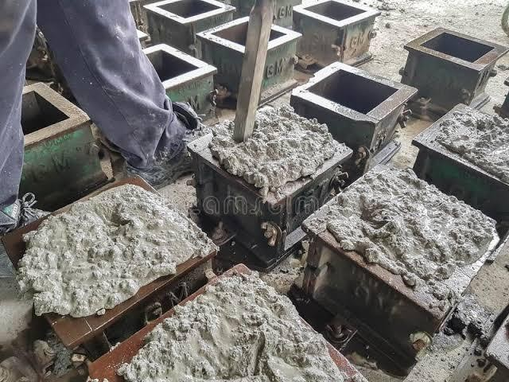FIG.4.1.3.(a) Compressive Strength FIG.4.1.3.(b) Cube Moulds

Fig :4.1.3 (C) casting

## Procedure:

* For this test mainly 150mm ×150 mm × 150 mm cubes are used
* Clean the moulds properly and apply oil inside the cube frame.
* Fill the concrete in the molds in layers approximately 50mm thick.
* Compact each layer with not less than 35 strokes per layer using a tamping rod (steel bar 16mm diameter and 600 mm long).
* Level the top surface and smoothen it with a trowel.
* The concrete cubes are removed from the moulds between 16 to 72 hours, usually this done after 24 hours. Remove the specimen from water after specified curing time and wipe out excess water from the surface.Take the dimension of the specimen to the nearest 0.2mm And then place the specimen in the machine in such a manner that the load shall be applied to the opposite sides of the cube cast. Align the specimen centrally on the base plate of the machine. Rotate the movable portion gently by hand so that it touches the top surface of the specimen.
* Apply the load gradually without shock and continuously at the rate of 140 kg/cm2/min. till the specimen fails.
* Record the maximum load and note it.

## Split Tensile Test

Since concrete is brittle, it is weak in tension and can cause cracks. So it is essential to conduct the tensile strength test of concrete. A method of determining the tensile strength of concrete using a cylinder which splits across the vertical diameter. It is an indirect method of testing tensile strength of concrete. At least three samples should be tested and an average value is calculated.

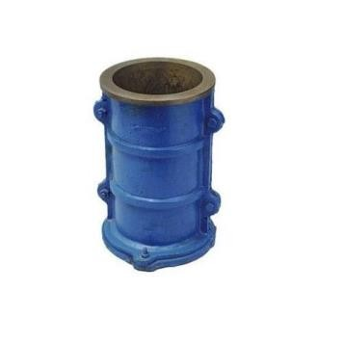

FIG-4.2(a): Split Tensile Test

## Procedure:

* The first step is to prepare the concrete mix for making the cylindrical specimen.
* Grease the inside surface of the mould and Pour the mix into the mould as layers.
* Compact each layer using a tamping rod. Tap each layer 30 times.
* Uniformly stroke the concrete mix and remove the excess concrete.
* Then immerse the casted specimen in water for 24 hours at 27-degree celsius.
* After that remove the specimen from the mould and immerse it in freshwater.
* The splitting tensile strength of concrete should be conducted at 7, 28 days of curing.
* Before starting the test, take the specimen from the immersed water and wipe the water.
* Then note the dimension and weight of the specimen.
* Place plywood strip above and below the specimen
* After that place the specimen on the testing machine.
* Then gradually apply load at a rate of 0.7 to 1.4 MPa/min (1.2 to 2.4 MPa/min based on IS 5816 1999).
* Record the load at which the specimen breaks.

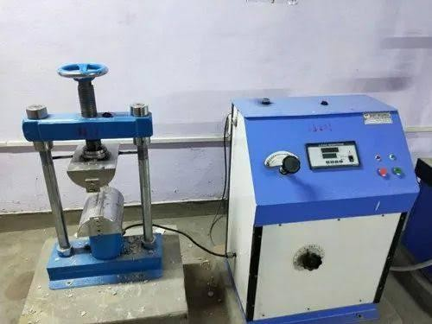

FIG-4.2 (b) Split tensile test apparatus

## 4.3 Slump Cone Test

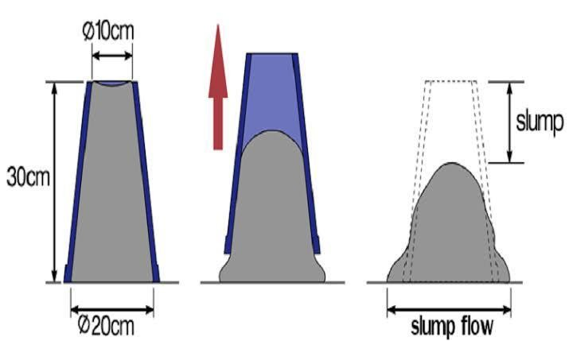The slump test is conducted to measure the consistency of concrete in that specific batch. Here, consistency of concrete refers to the workability or fluidity of freshly made concrete, and therefore it is a measure of the ease with which concrete flows. The Slump test concrete is carried out with the help of a conical cone open at both ends. The slump cone filled with concrete lifted up and the resulting height of concrete spread over the surface shows the degree of fluidity, workability, and consistency of the concrete mix. It also indicates the amount of water added is correct or not.The slump cone has an internal dia. 100 mm at the top and 200 mm at the bottom and the total height of the con is about 300 mm.

Fig-4.3 (a) slump cone test

## Procedure:

* First, the slump cone is placed on a hard non –water–absorbing surface. ( metal or concrete)
* The Slump cone is filled with freshly mixed concrete in three layers.
* Each layer of the concrete mix must be tapped with a 2 ft (600 mm)-long bullet-nosed metal rod measuring 5 8 in (16 mm) in diameter.
* After filling the last layer extra concrete must be removed from the top of the cone.
* The slump cone then quickly lifted upward with a twisting effect with both hands. The concrete is then free to fall.
* After free fall the remaining height is known as slump and is measured to the nearest 5 mm if the slump is 100 mm.

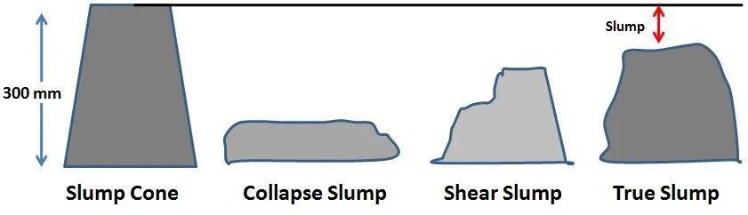

FIG-4.3(b):Types of Slumps

## 

## 4.4 MIX DESIGN

1. **Stipulations for proportioning:**
   1. Grade Designnation : M20
   2. Type of cement : OPC 43 grade
   3. Maximum nominal size of aggregates:20mm
   4. Exposure condition : Severe
   5. Workablity : 50 mm (slump)
   6. Type of aggregates : Cinder, LECA
   7. Max cement content : 450 kg/m³
   8. Chemical admixture type : No chemical admixture used

## Test data for materials:

* 1. Cement used : OPC 43 grade
  2. Sp. Gravity of Cement : 3.15
  3. Sp. Gravity of Fine aggregates : 2.65
  4. Sp. Gravity of LECA : 0.51
  5. Sp. Gravity of Cinder : 1.52
  6. Water absorption of FA : 1%
  7. Water absorption of LECA : 16.42%
  8. Water absorption of Cinder : 8.8%

## Target Strength for mix proportioning:

f’ck = fck + 1.6S (or) f’ck = fck + X

which ever is greater

Standard deviation (S) = 5 N/mm²

X = 5.5 N/mm² ( for M20 grade)

Therefore, Target Strength f’ck = fck+1.65S

=20+1.65×5 = 28.5 N/mm²

f’ck = fck+X

= 20+5.5 = 26.5 N/mm²

## Selection of water cement ratio:

* 1. Water cement ratio = 0.5
  2. water content = 186 kg for 20mm aggregates (for 50mm slump)
  3. Estimated water content = 191.6 kg/m³ ~ 192 kg/m³

## Calculation of cement content:

* 1. water cement ratio = 0.5
  2. Cement content = (192/0.5) = 384 kg/m³

## Proportion of Vol of aggregates conent:

* 1. Vol of CA as per table no.3 of IS 1062 = 62%
  2. Vol of LECA adopted = 40% of Vol of CA
  3. Vol of cinder adopted = 60% of Vol of CA
  4. Vol of FA = 38%

## Mix Calculations:

* 1. Vol of Concrete = 1m³
  2. Vol of Cement = (Mass of cement/ Sp.gravity of cement) × (1/1000)

= (384/3.15) × (1/1000) = 0.121 m³

* 1. Vol of water = (mass of water / sp.gravity of water) × (1/1000)

= (192/1) × (1/1000) = 0.192 m³

* 1. Vol of all in aggregates [(a-b)-c] = [(1-0.121)-0.192]

= 0.687 m³

* 1. Mass of LECA = 441.2 kg/m³
  2. Mass of Cinder = 661.8 kg/m³
  3. Total mass of Light weight aggregates = 1107 kg/m³

## Mix Proportions:

* 1. Cement = 384 kg/m³
  2. Water = 192 kg/m³
  3. Fine Aggregates = 727 kg/m³
  4. LECA = 441.2 kg/m³
  5. Cinder = 661.8 kg/m³

Table-4.4: Mix sampling

|  |  |
| --- | --- |
| **MATERIAL** | **MIX PROPORTION(KG/MM3)** |
| Cement | 49 |
| Sand | 490 |
| Lime | 133 |
| Gypsum | 28 |
| Aluminum  Power | 0.46 |

# CHAPTER-5

# RESULTS AND DISCUSSION

**Objective-1:** To construct economical buildings (cost comparison) by replacing clay bricks by AAC blocks.

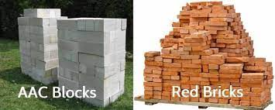

Fig-5(a): AAC blocks replaced with conventional bricks

AAC blocks are lightweight and easy to handle, which can significantly reduce labor costs during the construction process. Workers can move and install AAC blocks more efficiently than traditional clay bricks, leading to shorter construction times and lower labor expenses. AAC blocks have precise dimensions and smooth surfaces, which means less mortar is needed during construction. This reduction in mortar usage not only saves material costs but also reduces labor time spent on mortar preparation and application.

Due to their size and ease of handling, AAC blocks can be laid faster than clay bricks. This accelerated construction timeline can lead to savings on overhead costs, such as equipment rentals and site supervision.

AAC blocks offer excellent thermal insulation properties, which can lead to long-term energy savings for building occupants. This can be an attractive selling point for potential buyers or renters and may increase the overall value of the property.

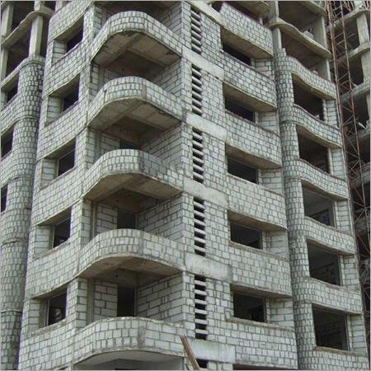

Fig-5(b): structure constructed with AAC blocks

AAC blocks are lightweight compared to traditional bricks, which reduces transportation costs. Lower weight means less fuel is required for transportation, leading to cost savings and a reduced environmental footprint. The lightweight nature of AAC blocks can lead to reduced foundation costs because they exert less load on the building's foundation compared to heavier materials like clay bricks or concrete blocks. AAC blocks can be easily cut and shaped on-site using standard tools, reducing the need for custom-made bricks or blocks. This versatility can save money on materials and labor. AAC block production is precise, resulting in minimal wastage during construction. This can translate into cost savings as fewer materials are wasted.AAC blocks are known for their durability, which means reduced maintenance and repair costs over the life of the building.

However, it's essential to consider that the cost savings with AAC blocks can vary depending on factors such as the project size, location, availability of AAC block suppliers, and the local labor market. It's also crucial to ensure that the AAC blocks are installed correctly to realize these potential cost savings fully.

In summary, AAC blocks can be a cost-effective alternative to clay bricks in construction, primarily due to their lightweight nature, ease of use, and transportation advantages. Careful planning and proper installation are essential to maximize the cost benefits of using AAC blocks in building projects.

**Objective-2:** To make productive use of recycled industrial waste (fly ash).

Using recycled industrial waste, such as fly ash, in the production of AAC (Autoclaved Aerated Concrete) blocks is a sustainable and environmentally friendly approach that can have several benefits. Here's how you can make productive use of recycled fly ash in AAC block manufacturing:

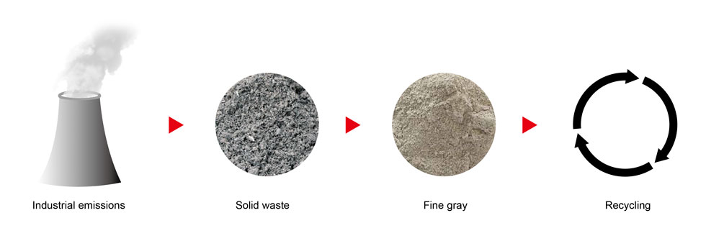

Fig-5(c) : Fly ash from thermal power plants

**Fly Ash as a Replacement for Raw Materials:**

Substitute a portion of the traditional raw materials (like cement and sand) used in AAC block production with fly ash. Fly ash can replace a significant percentage of these materials, which reduces the overall cost of production.

**Improved Material Properties:**

Fly ash can enhance certain properties of AAC blocks, such as reducing the density while maintaining strength. This can lead to lighter blocks with good insulation properties.

**Environmental Benefits:**

By using fly ash in AAC block production, you reduce the environmental impact associated with the disposal of fly ash in landfills or its release into the atmosphere. This approach promotes sustainability by recycling industrial waste.

**Compliance with Green Building Standards:**

Incorporating fly ash into AAC blocks can help meet green building and sustainability standards, making your construction projects more attractive to environmentally conscious customers and meeting regulatory requirements in some regions.

**Cost Savings:**

Fly ash is often less expensive than traditional raw materials. Therefore, using fly ash can result in cost savings for AAC block manufacturers.

**Quality Control:**

Ensure the quality and consistency of fly ash by working with reputable suppliers. Fly ash quality can vary, so rigorous quality control measures should be in place to maintain consistent AAC block quality.

**Testing and Certification:**

Conduct testing and certification to verify that AAC blocks made with recycled fly ash meet industry standards for strength, insulation, fire resistance, and other essential properties.

**Market Awareness:**

Educate your target market about the benefits of AAC blocks made with recycled fly ash. Highlight the environmental advantages, cost savings, and potential energy efficiency gains.

**Regulatory Compliance:**

Ensure that your use of fly ash complies with local regulations and environmental standards. This may involve obtaining permits or certifications related to the use of recycled materials.

**Research and Development:**

Invest in research and development to optimize the mix design for AAC blocks containing fly ash. This can help improve block quality and performance.

**Collaboration and Partnerships**:

Collaborate with local industries generating fly ash waste to establish a consistent and reliable supply chain. Building partnerships can help secure a steady source of fly ash.

**Waste Management:**

Implement effective waste management practices to handle any residual waste from the production process, ensuring minimal environmental impact.

Incorporating fly ash into AAC block manufacturing can be a win-win situation, benefiting both your business and the environment. It's essential to conduct feasibility studies, quality control, and market research to ensure successful implementation of this sustainable practice.

**Objective-3:** To cast standard AAC blocks in the laboratory and conduct various tests to check the strength and capacity of blocks.

**5.1**  **ANALYSIS OF SLUMP TEST RESULTS**

The slump test is carried out in order to determine the workability of concrete. Slump test is carried out for various proportions of LECA and Cinder.

60

**Slump Results**

55

53

50

50

48

46

42

39

40

37

31

33

30

27

20

10

0

0

10

20

30 40

50

60

70

80

90

100

**Aggregate Proportion (%)**

M20

**Slump (mm)**

FIG.5.1. Comparison of %Agrregate proportion V/S Slump

From the above slump values it is observed that the slump goes on increasing up to 40% replacement of leca and 60% replacement of cinder. Further the values of the slump goes on decreasing till the last proportion, therefore from the graph it is analysed that the slump is highest for the 40% leca and 60% cinder replacement proportion.

## ANALYSIS OF COMPRESSIVE TEST RESULTS

The aggregates are blended in a defined proportion starting from 0% to100% for replacement of natural coarse aggregates. For each replacement ratio specimen's cubes and cylinders were casted.

The elements were subjected to standard curing placing in water at ambient room temperature for 28 days. The cured cube specimens was subjected to compressive loadings and the corresponding strength characteristics were determined.

Here the Compressive Strength of Various proportions of M20 for different curing periods such as 7 days and 28 days are analyzed.

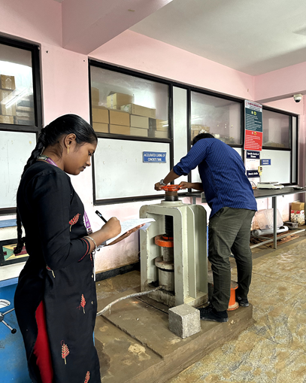

Fig :5.2 conducted compression test on cube

Table 5.2: Average Compressive Strength

|  |  |  |  |  |  |
| --- | --- | --- | --- | --- | --- |
| **Sl. No** | **Light Weight Aggregate** | | **Desnty (kg/mm³)** | **Avg Compressive Strength (N/mm²)** | |
| **% LECA** | **% Cinder** | **7 days** | **28 days** |
| 1 | 0 | 100 | 2325.92 | 22.560 | 30.910 |
| 2 | 10 | 90 | 2257.77 | 22.240 | 30.082 |
| 3 | 20 | 80 | 2219.26 | 21.110 | 29.330 |
| 4 | 30 | 70 | 2139.26 | 21.073 | 28.644 |
| 5 | 40 | 60 | 1837.00 | 19.475 | 28.892 |
| 6 | 50 | 50 | 1777.77 | 15.260 | 22.266 |
| 7 | 60 | 40 | 1751.11 | 14.969 | 20.856 |
| 8 | 70 | 30 | 1629.78 | 14.969 | 19.848 |
| 9 | 80 | 20 | 1629.63 | 13.952 | 19.443 |
| 10 | 90 | 10 | 1540.74 | 12.498 | 17.408 |
| 11 | 100 | 0 | 1454.81 | 12.208 | 17.018 |

**Compressive Strength n/mm²**

|  |  |  |  |  |  |  |  |  |  |  |  |
| --- | --- | --- | --- | --- | --- | --- | --- | --- | --- | --- | --- |
|  | 0 | 10 | 20 | 30 | 40 | 50 | 60 | 70 | 80 | 90 | 100 |
| 7 days | 22.5 | 22.2 | 21.1 | 21 | 19.4 | 15.2 | 14.9 | 14.2 | 13.9 | 12.5 | 12.2 |
| 28 days | 30.9 | 30 | 29.3 | 28.6 | 28.8 | 22.2 | 20.8 | 19.8 | 19.4 | 17.4 | 17 |

FIG.5.2 Comparison of %Aggregate proportion V/S Compressive Strength

35

30

25

20

15

10

5

0

**Aggregate Proportion (%)**

7 days 28 days

## ANALYSIS OF SPLIT TENSILE STRENGTH RESULTS

The cured cube specimens was subjected to Tensile loadings and the corresponding strength characteristics were determined.

Here the Split tensile Strength of Various proportions of M20 for different curing periods such as 7 days and 28 days are analyzed.

Table 5.3(a): Average Tensile Strength

|  |  |  |  |  |  |
| --- | --- | --- | --- | --- | --- |
| **SL.**  **No** | **Light Weight Aggregate** | | **Slump (mm)** | **Average Tensile**  **Strength (N/mm²)** | |
| **% LECA** | **% Cinder** | **7 days** | **28 days** |
| 1 | 0 | 100 | 27 | 1.87 | 2.64 |
| 2 | 10 | 90 | 31 | 1.85 | 2.62 |
| 3 | 20 | 80 | 33 | 1.85 | 2.61 |
| 4 | 30 | 70 | 48 | 1.78 | 2.52 |
| 5 | 40 | 60 | 55 | 1.66 | 2.43 |
| 6 | 50 | 50 | 53 | 1.45 | 2.05 |
| 7 | 60 | 40 | 50 | 1.34 | 1.89 |
| 8 | 70 | 30 | 46 | 1.10 | 1.56 |
| 9 | 80 | 20 | 42 | 0.96 | 1.36 |
| 10 | 90 | 10 | 39 | 0.85 | 1.20 |
| 11 | 100 | 0 | 37 | 0.83 | 1.1 |

|  |  |  |  |  |  |  |  |  |  |  |  |
| --- | --- | --- | --- | --- | --- | --- | --- | --- | --- | --- | --- |
|  | 0 | 10 | 20 | 30 | 40 | 50 | 60 | 70 | 80 | 90 | 100 |
| 7 days | 1.87 | 1.85 | 1.85 | 1.78 | 1.66 | 1.45 | 1.34 | 1.1 | 0.96 | 0.85 | 0.83 |
| 28 days | 2.64 | 2.62 | 2.61 | 2.52 | 2.43 | 2.05 | 1.89 | 1.56 | 1.36 | 1.2 | 1.1 |

FIG.5.3(a) Comparison of Aggregate proportion V/S Split Tensile Strength

3

2.5

2

1.5

1

0.5

0

**Aggregate Proportion (%)**

7 days 28 days

**Split Tensile Strength N/mm²**

Based on the results of the experimental investigation carried out, 60% of cinder & 40% of Leca has found to be optimum design mix for obtaining the designed concrete mix. In order to improve the compressive strength, for the same mix the 20% of cement was replaced by Ground Granulated Blast Furnace Slag which improved the compressive strength from 28.89N/mm2 to 30.20N/mm2. The mix proportions and results are tabulated below.

Table 5.3 (b): Mix Proportions for M20 grade of Light weight concrete with 20% GGBS

|  |  |  |
| --- | --- | --- |
| 1 | Cement | 306.4 kg/m³ |
| 2 | GGBS | 76.6 kg/m³ |
| 3 | Water | 191.6 kg/m³ |
| 4 | Fine Aggregates | 727 kg/m³ |
| 5 | Light Weight Aggregates | 1103 kg/m³ |
| 6 | Water cement ratio | 0.50 |

Table 5.3(c): Compressive strength of M20 grade of Normal aggregates concrete & LWC with 60% Cinder, 40% LECA as aggregates with 20% GGBS

|  |  |  |  |
| --- | --- | --- | --- |
| **Compressive Strength of Normal Concrete (N/mm²)** | | **Compressive Strength of Light Weight Concrete (N/mm²)** | |
| **7 days** | **28 days** | **7 days** | **28 days** |
| 23.54 | 34.62 | 21.90 | 30.34 |
| 23.05 | 34.28 | 21.87 | 30.27 |
| 22.96 | 34.05 | 21.69 | 31.45 |

A total of 27 AAC blocks of actual size 600x200x200 mm from the same lot were collected from a manufacturing industry to prepare the specimens. A total of 18 cubic specimens of edge length 150 mm were prepared in order to evaluate the compressive strength of AAC block following IS 6441. A total of 9 cylindrical specimens of 75 mm diameter and 150 mm length were used for evaluating the splitting tensile strength of AAC block.

The different types of cement-sand mortar used in this study are as follows:

1. MI (strong mortar); cement to sand ratio by weight=1/2

2. M2 (medium strength mortar); cement to sand ratio by weight=1/4

3. M3 (weak mortar); cement to sand ratio by weight=1/6

In India, the construction of the AAC wall is generally carried out using M2 and M3 cement-sand mortars.

Table-5.3(d) : Compressive strength test results of AAC masonry

|  |  |  |
| --- | --- | --- |
| S.NO | MORTAR TYPES | COMPRESSIVE  STRENGTH (MPa) |
| 1 | M1 | 34.2 |
| 2 | M2 | 18.3 |
| 3 | M3 | 9.4 |

A typical failure pattern of the masonry prism observed under compression load can be classified into two types

Type A: Vertical splitting cracks

Type B: Combination of cone and shear failure

Table: compressive strength test results of AAC masonry

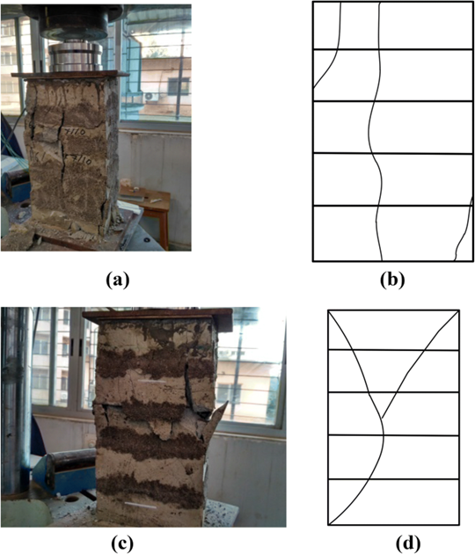

Figure-5.3(b) : A typical failure behavior of AAC Block masonry (a,b) vertical splitting crack, (c,d) combination of cone and shear failure.

* 1. **Tensile bond strength Test results**

The failure patterns observed during the tensile bond strength test on the couplet specimens were as follows:

(1) Thorough block mortar interface failure (Type A);

(2) Partial block-mortar interface failure (Type B) and,

(3) Thorough block failure (Type C).

Table-5.4: Tensile bond strength

|  |  |  |
| --- | --- | --- |
| Mortar type | Tensile load(KN) | Tensile bond strength(N/mm2) |
| M1 | 1.82 | 0.182 |
| M2 | 0.59 | 0.059 |
| M3 | 0.20 | 0.020 |

**Objective-4:** To analyze and compare between AAC blocks and conventional clay bricks.

Analyzing and comparing AAC (Autoclaved Aerated Concrete) blocks and conventional clay bricks involves assessing various factors, including cost, properties, sustainability, and performance. Here's a comprehensive comparison between the two building materials:

**1.Composition:**

AAC Blocks: AAC blocks are made from sand, cement, lime, and aluminium powder. They are autoclaved to create a lightweight, cellular structure.

Clay Bricks: Conventional clay bricks are made from natural clay, shale, or a mixture of both, and they are fired in a kiln.

**2. Weight:**

AAC Blocks: AAC blocks are lightweight due to their cellular structure, making them easier to handle and transport.

Clay Bricks: Clay bricks are heavier, which can increase transportation costs and require more labor for handling.

**3. Thermal Insulation:**

AAC Blocks: AAC blocks provide excellent thermal insulation properties, resulting in energy savings in heating and cooling.

Clay Bricks: Clay bricks have lower thermal insulation properties, which may require additional insulation materials in construction.

**4. Strength:**

AAC Blocks: AAC blocks have good compressive strength and can be engineered for specific load-bearing purposes.

Clay Bricks: Clay bricks have high compressive strength, making them suitable for load-bearing walls.

**5. Size and Dimensional Accuracy:**

AAC Blocks: AAC blocks have precise dimensions and uniform shape, reducing the need for mortar and speeding up construction.

Clay Bricks: Clay bricks may have slight dimensional variations, requiring more mortar and effort during construction.

**6. Environmental Impact:**

AAC Blocks: AAC blocks are considered environmentally friendly because they use less raw material, generate less waste, and often incorporate recycled materials like fly ash.

Clay Bricks: The production of clay bricks consumes more energy, and mining clay can result in habitat disruption. However, fired bricks can be recycled.

**7. Sound Insulation:**

AAC Blocks: AAC blocks offer good sound insulation properties due to their cellular structure.

Clay Bricks: Clay bricks provide moderate sound insulation but may require additional acoustic treatments.

**8. Fire Resistance:**

AAC Blocks: AAC blocks are non-combustible and have excellent fire resistance.

Clay Bricks: Clay bricks are also non-combustible but may deteriorate over time due to exposure to extreme heat.

**9. Cost:**

AAC Blocks: AAC blocks may have a higher initial cost compared to clay bricks but can result in cost savings in terms of labor, transportation, and energy efficiency over the long term.

Clay Bricks: Clay bricks are often more affordable initially but may incur higher labor and energy costs during construction and use.

**10. Installation:**

AAC Blocks: AAC blocks are easy to handle and install, leading to shorter construction times.

Clay Bricks: Installing clay bricks can be more labor-intensive and time-consuming due to their weight and varying dimensions.

**11. Sustainability:**

AAC Blocks: AAC blocks are considered sustainable due to their reduced resource consumption, lower energy requirements, and the potential to incorporate recycled materials.

Clay Bricks: Clay bricks can be sustainable if sourced locally and made with responsible clay mining practices.

In summary, the choice between AAC blocks and clay bricks depends on various factors, including project requirements, budget, environmental considerations, and local availability. AAC blocks offer advantages in terms of insulation, ease of construction, and sustainability, while clay bricks have a long history of use and may be more cost-effective in certain situations. Careful evaluation of specific project needs is essential when making this decision.

**5.5 How To Avoid Cracking In Walls With AAC Blocks.**

* The lightweight of **AAC Blocks** is undoubtedly a boon for the construction industry. This feature is a blessing as it comes with numerous benefits while it also poses challenges related to the shrinkage of the masonry and movement in the structural members of the building.
* After using bricks and stones for masonry construction for many years, came concrete blocks, hollow blocks, and fly ash bricks. AAC blocks have now carved their niche in the [**history of masonry construction**](https://www.ecorex.in/blogtopic/a-brief-history-of-masonry-construction-ecorex)**.**
* All masonry ingredients require a particular skill so do AAC blocks. Notably, there are a few small differences between brick masonry and AAC block masonry.
* Provide the band beam (1.2m height from the floor level) and stub column is provided if wall length is >6m.

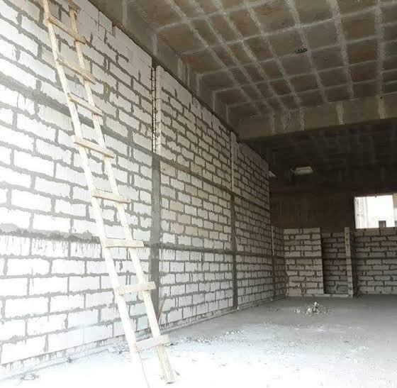

Fig-5.4(a): band beam and stub columns

* The AAC block masonry wall develop cracks due to thermal changes, the chicken mesh used to avoid cracks.

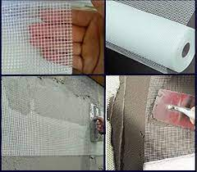

Fig-5.4(b): chicken mesh

* This AAC block adhesive (cement, lime, sand and specialized polymers) has more advantages over conventional cement mortar when used with AAC block.

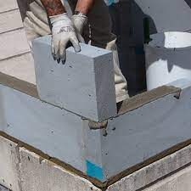

Fig-5.4(c): Adhesive

* 1. **Advantages and Disadvantages of AAC blocks**

**5.6.1 Advantages of AAC blocks:**

1. Eco-Friendly and Sustainable

The use of recycled industrial waste (fly ash), non-toxic ingredients, no emitting gases, and fewer energy consumptions makes the ACC Blocks eco-friendly and sustainable.

2. Lightweight

The AAC Blocks are 3 to 4 times lighter than bricks, 30% lighter than that of concrete which helps in reducing the dead load of the building, thereby allowing construction of taller buildings.

3. **Thermally Insulated & Energy Efficient**

Tiny air pores and thermal mass of blocks provide excellent thermal insulation, thus reducing heating and air conditioning costs of a building.

4. **Fire Resistant**

Non-combustible and fire-resistant up to 1600° C which can withstand up to 6 hours of direct exposure.

5. **Acoustic Performance**

As the AAC block is porous in nature, the sound absorption quality is superior. It offers sound attenuation of about 42 dB, blocking out all major sounds and disturbances which makes it ideal for schools, hospitals, hotels, offices, multi-family housing and other structures that require acoustic insulation.

6. **Easy Workability and Design Flexibility**

AAC blocks can be easily cut, drilled, nailed, milled and grooved to fit individual requirements.

**7. Seismic Resistant**

Lightweight blocks reduce the mass of a structure, thus decreasing the impact of an earthquake on a building. Non-combustible nature provides an advantage against fires, which commonly accompany earthquakes.

**8. Faster Construction**

Construction of AAC Blocks reduces the construction time by 20%. As different sizes of blocks help reduce the number of joints in wall masonry. The lighter weight of the blocks makes it easier and faster to transport, place and construct the masonry.

**5.6.2 Disadvantages Of AAC Blocks**

1. Installation during rainy weather aircrete is known to crack after installation, which can be avoided by reducing the strength of the mortar and ensuring the blocks are dry during and after installation.
2. As the AAC Blocks are brittle nature, they need to be handled more carefully than clay bricks to avoid breakage.
3. The brittle nature of the blocks requires longer, thinner screws when fitting cabinets and wall hangings and wood-suitable drill bits or hammering in.
4. Insulation requirements in newer building codes of northern European countries would require very thick walls when using AAC alone. Thus many builders choose to use traditional building methods installing an extra layer of insulation around the entire building.

**CHAPTER-6**

# CONCLUSION

Based on the results of the experimental investigation carried out and in scope of work carried out, the conclusions are drawn.

1. To construct economical buildings (cost comparison) by replacing clay bricks by AAC blocks.

* AAC blocks can help reduce construction time and labour costs due to their lightweight and
* easy-to-use design. Additionally, using autoclaved aerated concrete blocks can save money
* on transportation costs, as they are lighter and require less fuel to transport compared to
* traditional building materials

1. To make productive use of recycled industrial waste (fly ash).

* AAC blocks can help reduce construction time and labour costs due to their lightweight and
* easy-to-use design. Additionally, using autoclaved aerated concrete blocks can save money
* on transportation costs, as they are lighter and require less fuel to transport compared to
* traditional building materials

1. To cast standard AAC blocks in the laboratory and conduct various tests to check the strength and capacity of blocks.

* As per the Indian Standard code IS 2185 (Part 3), there are several tests that need to be conducted on AAC blocks to ensure that they meet the required standards. These tests include:
* Compressive strength test: This test determines the load-carrying capacity of AAC blocks under compression. The minimum compressive strength of AAC blocks as per IS code is 3 N/mm².
* Water absorption test: This test determines the ability of AAC blocks to absorb water. The maximum water absorption limit as per IS code is 10% of the dry weight of the block.
* Dimension test: This test ensures that the dimensions of the AAC blocks are within the required tolerances.

1. To analyze and compare between AAC blocks and conventional clay bricks.

* AAC blocks are lighter and more efficient than clay bricks. AAC blocks are not only economical but also good for the environment. There are millions of small air bubbles inside the AAC blocks which make them lighter. With the right process, it is also made stronger than clay bricks AAC blocks reduce outside noise and heat, making your home noise-free, and keeping it cool in the summer and warm in the winter. Earthquakes have less impact on buildings constructed  using AAC blocks. The risk of a fire spreading throughout the structure is also less.

Table-5.5: comparison between AAC blocks and clay bricks

|  |  |  |
| --- | --- | --- |
| **Parameter** | **AAC Block** | **Clay Bricks** |
| **Structural Cost** | Steel Saving Upto 15% | No Saving |
| **Cement Mortar for Plaster & Masonry** | Requires less due to flat, even surfaces & less number of joints | Requires more due to irregular surface and more number of joints. |
| **Breakage** | Less than 5% | Average 10 to 12 % |
| **Construction speed** | Speedy construction due to its big size, light weight & ease to cut in any size or shape | Comparatively slow |
| **Quality** | Uniform & Consistent | Normally varies |
| **Fitting & Chasing** | All kind of fitting and chasing possible | All kind of fitting and chasing possible |
| **Carpet Area** | More due to less thickness of walling material | Comparatively low |
| **Availability** | Anytime | Shortage in monsoon |
| **Energy Saving** | Approx. 30% reduction in air-conditioned load | No such saving |
| **Chemical Composition** | Sand/Flyash used around 60 - 70 % which reacts with Lime & Cement to form AAC | Soil is used which contains many inorganic impurities like sulphates etc. resulting in efflorescence |

**CHAPTER-7**

# FUTURE SCOPE

* A further research for development of new technologies in composite construction such as slim-floor slabs with semi continuous connections to the columns, new steel sheets or systems to minimize the time of erection and assembly is desirable.
* The idealizing assumption of beam-to-column connections as hinged or fully rigid due to lack of more realistic guidance in view of modeling advocates for further research on non- linear response of joints considering rotational stiffness, moment of resistance and rotational capacity. Preparation of guidelines for modeling different type of connections may also prove very helpful.
* Preparation of miniature specimens for testing may be thought of to avoid costly experimentation generally carried out on full size models to known the exact behavior of steel-concrete composite structural elements. A numerical analysis of the same will also be highly desirable to correlate the data and result.
* % Recent development in composite construction technology, which have successfully transformed the market place in other countries, providing added value to the customers and rapid return on the invested capital. These, if adopted in India for residential and commercial building, could be very beneficial to the Indian community. In this regard, development of suitable design aids may be very fruitful.
* The use of precast concrete and even the prestressed concrete component in certain composite structure applications may prove fruitful as it has potential
* due to the economy that can be achieved by these components in terms of time, labour and money.
* More complicated type of truss geometries can be tried. The through type of composite truss can be attempted with a few modifications in analysis and design procedure.
* Some of the GA operators like inversion dominance segregation, deletion, duplication, etc. which could not be implemented in the present work may be considered.
* Hybridization of different soft computing tools such as Artifical Neural Network, Genetic Algorithms and Fuzzy Logic may be tried. The use of hybrid methods like Neuro-Genetic, Fuzzy-Genetic, Neuro-Fuzzy-Genetic, etc. may prove fruitful in optimization of composite construction.
* Due to the iterative nature of the algorithm, a large number of mathematical calculations are required to be performed in GA based optimization which makes it computationally inefficient. This problem can be avoided by using parallel/distributed processing environment.
* The GA based composite frame program provides facility to select composite sections from design tables of only two countries i.e. India and UK. Attempt may be made to add design tables of other countries.
* GA based optimum design of composite space frame can be tried. However, large number of design variables will slow down the optimization process considerably.
* Different types of composite columns can be simulated under various loading conditions using FEM and a database may be created for its practical use.
* Research in the field of fire resistance of composite structure is desirable to maximize their potential use and to clearly understand how steel and concrete progressively lose strength and stiffness at elevated temperatures.
* The use of fiber reinforced concrete, high strength concrete, self compacting concrete etc. instead of the conventional concrete may be explored in steel-concrete composite construction.
* Evaluation the performance of members, connections and connectors (e.g., shear connectors) under severe cyclic and dynamic loading including shakedown behavior is another field which may be of interest to the researchers.
* A hypothetical model or a program can be developed for design and analysis of composite column that can be run as an external program in the STAAD.Pro software.
* The earthquake response of steel and composite building structures is a subject of much interest; therefore there is much scope for research on the use of composite structures in seismic areas. The use of fully and partially encased steel sections in reinforced concrete is particularly beneficial for earthquake-resistant design. A further study on the suitability of other types of composite structural systems for earthquake-resistant design is highly recommended.
* The wind analysis of multi-storied composite structure can be carried out and charts can be prepared for various wind pressure.
* Non-linear dynamic analysis can be carried out of various types of composite structure.
* Composite moment frame, consisting of steel beam and reinforced concrete column is one type of hybrid system. Detailed parametric study of such systems under different types of loadings is highly desirable.
* Seismic analysis and design of a composite G+30 storey or higher may throw some more light on the cost effectiveness and efficiency of such structures.
* Detailed study of various types of composite bridges is another area which requires immediate attention.
* A detailed study on beam with web opening, cellular and castellated beam, stub girder, tapered fabricated beams, hauched beam in composite construction and comment on their suitability under various conditions will be certainly helpful to the people involved in the building industry.
* Design rules for composite construction have been developed gradually over the years and have been undergoing improvements and updating till today. These progressive changes resulted in more efficient uses of the constituent materials and led to better, less expensive structures. There is no doubt that the search for further improvements in this field will be certainly beneficial because it has very wide scope for further development.

**CHAPTER-8**

# REFERENCES

1. Hossein Fashandi, Hamid Reza Pakravan, Masoud Latifi (2019) “Application of modified carpet waste cutting for production of eco-efficient Light Weight Conctete”.
2. Behnam Vakhshouri, Shami Nejadi (2018) “Size Effect and Age factor in mechanical Properties of BST Light Weight Concrete”.
3. K. Dhir, R. G. C.Mays, and H. C. Chua, 1984, Lightweight Structural Concrete with Aglite aggregate: mix design and properties, International Journal of Cement Composites and Lightweight Concrete, Vol 6, (4) Nov. 1984, 249-260.
4. Juan Daniel Martinez, Santiago Betacourts- paraa, Ivonne carvajal-marin (2018) “Ceramic Light Weight Aggregrate product from Petrochemical waste and carbonate as expansion agents ”.
5. Yuan Ren, Zhenpeng Yu, Qia Huang, Zheng Ren ,(2018) “Constitutive model and failure criterions for Light weight aggregrate concrete –A true triaxial experiments test.”
6. K.M.A.Sohel, K.A.Jabri, M.H.Z hang, 2018) “Flexural Fatique behavior of ultra lightweight cement composite and high strength light weight aggregrate concrete.”
7. Zhenyu Huang, Krishnan Padmaja, Shan Li (2018) “Mechanical properties and microstructure of ultra light weight concrete composite with flyash cenosphere after exposure to high temperature.”
8. C.Pla, A.J.Tenja Abril, J.Valdes-Abellan (2018),“ Influence of microstructure on fluid transport and mechanical properties in structural concrete produced with light weight clay aggregate.”
9. Noureddine latroch, Yassine Senhadiji (2018), “ Physico-mechanical and thermal properties of composite mortars containing light weight aggregate of expanded polyvinyl chloride.”
10. R.N.F.Carmo, H.Costa (2018) ,“ Influence of light weight aggregate concrete on the bond strength concrete-to-concrete interfaces’’.
11. Hatice Oznur Oz(2018) “Properties of previous concrete partially incorporating acidic
12. pumice as coarse aggregate’’
13. Gemma Rodriquezde Sensale, Lliana Rodriguez Viacava(2018) “A study on blended Portland cement containing residual rice husk and limestone filler”.
14. Nafise Hosseini Balam, Mohamdreza eftekhra(2017) “Effective of bacterial remediation on compressive strength, water absorption and chloride permeability of light weight aggregate concrete ”.
15. Danuta-Barnat, Malgorzata franus(2017) “The use of zeolite, light weight aggregate and boiler slag in restoration renders”.
16. PeiyaonLiu, Rifat Farzana, Veena Sahajwalla(2017) “Light weight expanded aggregate from the mix of waste automotive plastics and clay”
17. Yuanhang Chen(2017) “A mix desihn method of light weight aggregate self-compacting concfrete based on packing and mortar film thickness theories”
18. H Ceilikozyildirium, 2000, Laboratory Investigation on Mechanical properties of Light Weight Aggregate Concrete, Euro Lightcon, Economic Design And Constructive With Light Weight Aggregate Concrete Document, BE96-3942/R23, June 2000.
19. Ana M Bastos ,Hipolito Souse and Antonio F.Melo, 2005, Methodology for the Design of Light Weight Concrete with Expanded Clay Aggregates, TMS JOURNAL.
20. W GMoravia , C.A.S Oliveria , A.G Gumieri , W.L Vasconcelos , 2006, Micro Structural Evaluation Of Expanded Clay To Be Used The Aggregate In Structural Concrete, Ceramics Vol.52 June 2006.
21. Fahrizalzulkarnain, Mahyuddinramli, 2008, Durability Of Light Weight Aggregate Concrete For Housing Construction, 2nd International Conference on Built Environment In Developing Countries (ICBEDC 2008).
22. Mouli M, Khelafi H, 2008, Performance Characterizes Of Lightweight Aggregate Concrete Containing Natural Pozzolan, Build. Environ. Vol 43, 31-36.
23. Khandaker M. Anwar Hossain, 2008, Blended Cement And Light Weight Concrete Using Scoria :Mix Design, Strength, Durability And Heat Insulation Characteristics, International Journal of Physical Sciences, Sept 2008.
24. 87 10262 (2009): Guidelines for concrete mix design proportioning.
25. V. Khonsari, E. Eslami & Ah. Anvari, 2010, Effects of expanded perlite aggregate on the mechanical behavior of light weight concrete, Proceedings of Fracture Mechanics of
26. Concrete and Concrete Structures, March 2010, 1354-1361.
27. Ling I H ,Teo D.C.L, 2012, Compressive Strength Of And Durability Property Of Light Weight Concrete, International Journal Of Sustainable Energy Development, Volume 1, Dec 2012.
28. Jihad Hamad Mohammed, Ali Jihad Hamad, 2014, A Classification Of Lightweight Concrete: Materials, Properties And Application Review, International Journal of Advanced Engineering Applications, Vol.7, Iss.1, 2014, 52-57.
29. Alireza Motamednia, Vahid Nasiri, Rasoul Jani, 2013, Laboratory
30. Investigation On Light Weight Concrete Against Acids, Research Journal Of Chemical And Environmental Studies, Volume 1, Aug 2013.
31. S. Sivakumar And B. Kameshwari, 2015, Influence Of Flyash, Bottom ash and Light Expanded Clay Aggregate On Concrete, Advances In Material Science And Engineering.
32. Raymond T, Hemmings , Bruce J ,Cornelius, 2009, Comparative Study Of Light Weight Aggregates, World Of Coal Ash Conference, May 2009.
33. Dr. V Bhaskar Desai, Mr. A Satyam, 2014, Some Studies On Strength Properties Of Light Weight Concrete, International Journal Of Scientific And Research Publications, Volume 4, Feb 2014.
34. Laksmi kumar Minapu, M K MV Ratnam, Dr U Rangaraju, "Experimental study on Light Weight Aggregate Concrete with Pumice stone, silica fume and fly ash as a partial replacement of coarse aggregate" International Tournal of Innovative Research in Science, Engineering and technology, Vol 3, Issue 12, Dec 2014, ISSN 2319-8753, PG 18130- 18138.
35. Binyu Zhang, Chi Sun Poon, "Sound insulation properties of rubberized light weight aggregate concrete" Journal of Cleaner Production, Vol 172,
36. 20 Jan 2018, PG 3176-3185.
37. Canan Jasdemir, Ozkan Sengul, Mehmet Ali Tasdemir, "A Comparative study on the thermal conductivities and mechanical properties of light weight concretes" Energy and Buildings, Volume 151,15 September 2017, PG 469-475.
38. Hemant K Sarje, Amol S Autade, "Study of performance oflight weight concrete", International journal of latest trends in engineering and technology, ISSN: 2278-621X, Vol 4, Issue 4, Nov 2014, PG 139-141.